Oregon Library Association 2014
A Walk in the Park: Nature-Based Library Programs

Natasha Forrester, Multnomah Co. Youth Librarian, natashaf@multcolib.org 503-988-6993
Jane Corry, Multnomah Co. Youth Librarian, janec@multcolib.org 503-988-5382

There is a growing body of evidence, though, that indicates kids today have a lot less exposure to nature than previous generations. There are a lot of reasons for this:

- technology: TV, computers, video games, phones, etc. According to the National Institutes of Health, children spend 3-7 hours a day in front of a screen of some kind. and as few as 30 minutes in unstructured outdoor play each day.

- heavily-scheduled children: after-school activities and classes, plus more homework all add up to less time to just be outside. Even recess isn’t always an effective way to let kids be outside - only 4 states mandate recess, and the average number of minutes of recess per day is 26 minutes, including eating their lunch.

- urbanization: more people living in towns and cities than in the country - 80% of the US population lives in urban areas. In addition, since 2008, over 100 state parks have closed or experienced reduced hours and staffing.
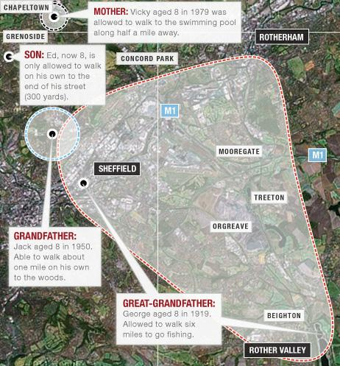

Why does it matter?
- Over the last few decades concentration, creativity and empathy have all measurably decreased.
- Since the 1950’s, depression and anxiety in children have increased 5-8 times.
- Suicide rates have doubled for young adults ages 15-24, and have quadrupled for children under 15.

Are these things caused solely by what author Richard Louv dubbed “Nature Deficit Disorder”? No, absolutely not. But there is also a growing body of evidence that a disconnect with nature influences these things, and that kids who do have exposure to nature have advantages over kids who don’t. Some possible benefits include:

- increase in physical activity, and “big body play” i.e. running, jumping, roughhousing, wrestling - the loud stuff that helps kids master things like regulating their bodies, where they end and other people and objects start, interpreting nonverbal cues, etc.
- reduced stress and increased feelings of well-being (anyone read When Sophie Gets Angry...Really, Really Angry?) - this applies to being in city green-spaces just as much as a walk in the country or a hike up the mountain.
to 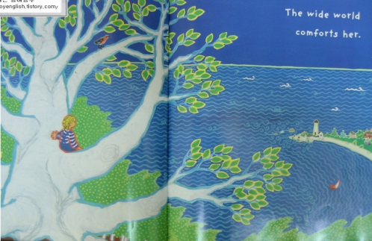
- increased concentration and self-discipline after contact with nature, including for children diagnosed with ADHD
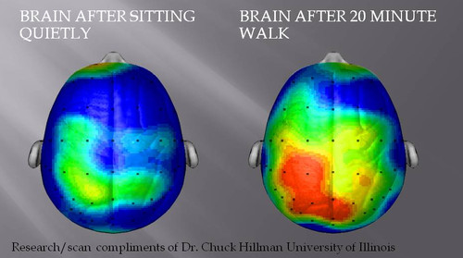
slide of brain after walking 20 minutes
- increased use of imagination, creating their own games, rules,etc., leading to more creative and diverse play, and increased language use and skills
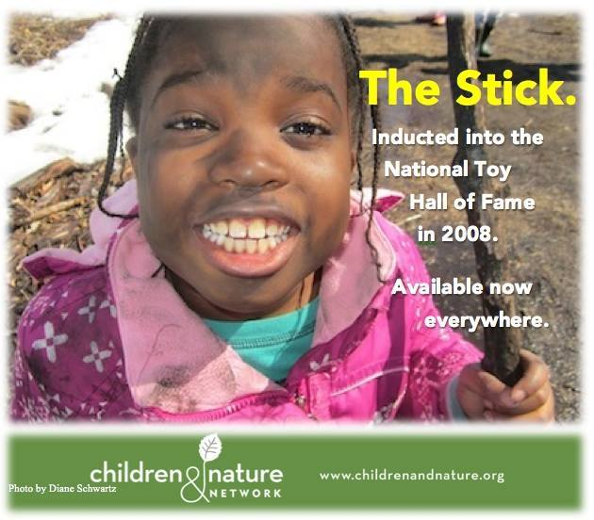

- kids exposed to nature grow up to be more conscious of it and better conservators.

How can libraries help?
Give kids exposure to nature through programming. This can involve a LOT of different things and be done a LOT of different ways, so we encourage you to think about programming from this angle, use it as an opportunity to add some STEAM elements, and to look at community partnership opportunities. And today we’ll share some of the stuff we’ve tried, and then have a little time for brainstorming or sharing things you’ve either tried or want to do!
~program descriptions~
- Incorporate nature themes in displays and bulletin boards
- Talk about nature in programs
  - use video clips or sound files
  - Use books on nature, pairing fiction and nonfiction
  - use natural items like rocks, leaves, dirt, flowers, seeds, feathers, etc. in programs
- Hold “regular” programs outside when you have the space - partner with parks, nearby schools, etc.
  - Host a “Fun Day” where you put out “tools” like traffic cones, balls, hula hoops, and pool noodles and let the kids make up their own games (or have teen volunteers help guide them)
  - Have concerts on the lawn (we called ours “Mow-town” because we’re cheesy)
  - Try a StoryWalk - contact natashaf@multcolib.org for more information
- Host specifically nature-related programs: leaf painting, the Bug Chicks and other natural world paid performers; plant seeds (Jane recommends radishes because they germinate quickly); explore different sizes in the animal kingdom since many kids just see pictures of birds, elephants, etc.
- Partner with other organizations:
  - 11 counties have nature centers
  - 100 state parks and natural areas in the state
  - all counties have extension offices (gardening and forestry)

Sharing time
Ideas I want to try!
- map the neighborhood
- hula hoop observation
- make birdfeeders
- talk to patrons - find people with a passion and have them do a program
- Bike parade

More info
Quick intro to STEAM - science, technology, engineering, art, and math. These subject areas teach skills that are vital to many growing industries, but more importantly, they help kids grow into being curious, observant, risk-taking, problem-solving people in general. It means encouraging kids to explore, observe, ask questions, make predictions, and create solutions - things that are a perfect fit with library programs!
- science: making observations, making predictions, asking questions
- technology: using tools - iPads and hammers are both tools
- engineering: building things, figuring things out and problem solving
- art: creating, taking risks, seeing what happens
- math: estimating, measuring, classifying, comparing/contrasting

Visual thinking strategies - use modified versions of these questions:
- What's going on in this picture? (What is going on in your experiment?)
- What do you see that makes you say that?
- What more can we find?

Headband activity

Activity stations:
- leaf rubbing
- StoryWalk stands
- magnifying glasses with sticks, leaves, rocks, etc. - play dough to press them into
- shapes in nature scavenger hunt
- iPad with WonderWorks website
- Abracadabra storytime song - wind, clouds, rain, grass
- fiction and nonfiction storytime books with nature concepts
- rock exploration
- worms and dirt

