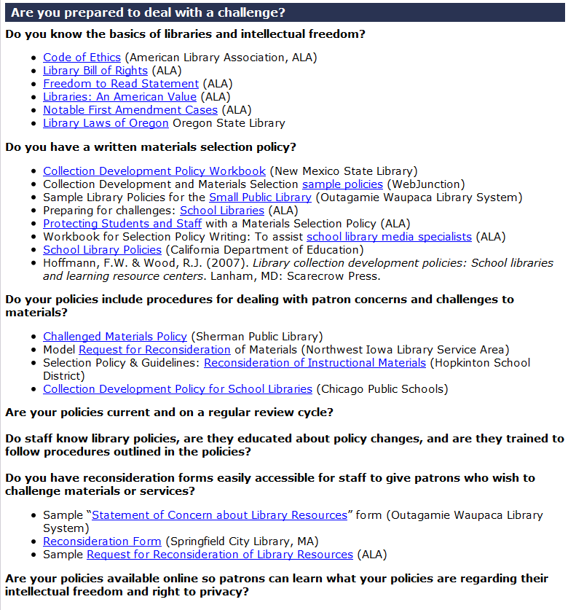
Katie Anderson, Library Development Services
katie.anderson@state.or.us, 503-378-2528

Oregon Intellectual Freedom Clearinghouse: http://www.oregon.gov/osl/LD/Pages/intellectual.aspx
