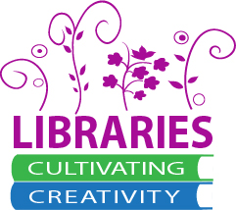
Discovery Layers in Action
April 17, 2015
OLA Conference
Eugene, Oregon

Resources
List of libraries using which product http://www.librarytechnology.org/discovery.pl
Breeding, Marshall. "The Future of Library Resource Discovery." 1 Feb. 2015. Web. 16 Apr. 2015. http://www.niso.org/apps/group_public/download.php/14487/future_library_resource_discovery.pdf
Enis, Matt. "Open Source Picks Up the Pace : Library Systems Landscape 2015." Library Joural 7 Apr. 2015. Web . http://lj.libraryjournal.com/2015/04/technology/open-source-picks-up-the-pace-library-systems-landscape-2015/#_
The impact of Serial Solutions' Summon™ on information literacy instruction: Librarian perceptions. S Buck, M Mellinger - Internet reference services quarterly, 2011. http://www.tandfonline.com/doi/abs/10.1080/10875301.2011.621864#.VTPcRpOVnEY
Paths of discovery: comparing the search effectiveness of EBSCO Discovery Service, Summon, Google Scholar, and conventional library resources. AD Asher, LM Duke, S Wilson - College & Research Libraries, 2012. http://crl.acrl.org/content/early/2012/05/07/crl-374.short

Presenters:
Emily Cable, Salem Public Library, ecable@cityofsalem.net
Stefanie Buck, Oregon State University, Stefanie.Buck@oregonstate.edu
Steph Miller, Multnomah County Library, stephaniem@multcolib.org
Wylie Ackerman, Deschutes Public Library, wyliea@deschuteslibrary.org

