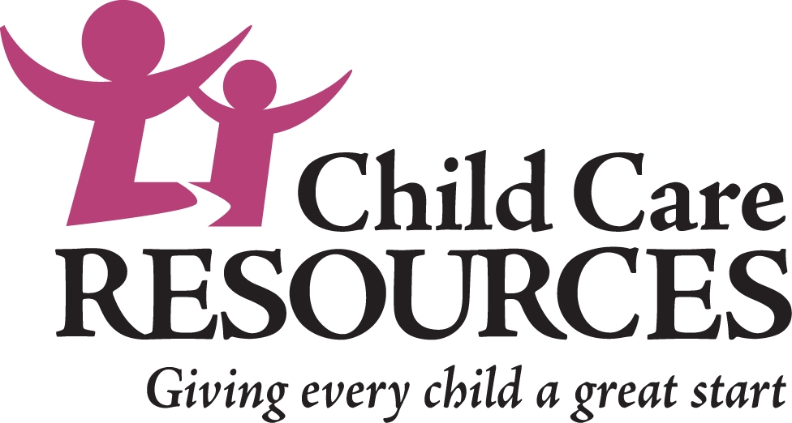

Play & Learn
Supporting Family, Friend & Neighbor Caregivers
and the Children in their Care

Background
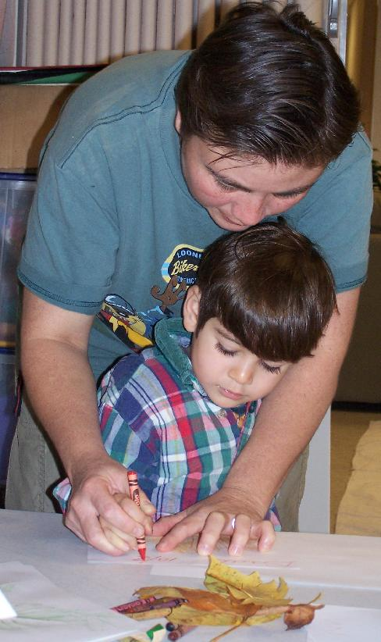
An estimated 60,000 children in King County and as many as 50% of children in refugee and immigrant families are cared for primarily by family, friends and neighbors while their parents work or go to school. Family, friend and neighbor caregivers play an essential role in contributing to children’s healthy development, early learning, school readiness and later school and life success.

Play & Learn has emerged as a model to support these caregivers and the children in their care. The approach is holistic, taking into consideration the needs of both the child and the caregiver for learning and support.

What is Play & Learn?
Play & Learn are facilitated play groups for young children and their caregivers. Play & Learn groups are run by community organizations in a variety of locations including libraries, community centers, family support centers, etc. In King County, there are over 45 Play & Learn groups offered each week in 9 different languages.
For young children, play and learning are not separate. Play is learning. Through play, children explore their world, discover how to get along with others, test their skills and muscles, try out new ideas and build confidence to try different activities.
Good Beginnings - Hawaii

Play & Learn group facilitators have backgrounds in child development and early education. The facilitator guides the children and adults through group and individual activities focused on developing early learning skills.

Everyone learns at a Play & Learn group:
- Children learn through developmentally-appropriate play with their peers and their caregivers
- Caregivers learn about the value of play in children’s development and how to promote early literacy and school readiness through everyday activities at home
- Caregivers learn about child development, community resources, and other topics relating to the joys and challenges of caring for young children
- Children and caregivers connect with others in similar circumstances to build supportive friendships.

What Happens at a Play & Learn Group
Each Play & Learn group is unique, reflecting the cultural community and organization where it is located. Play & Learn groups typically meet once or twice a week for 1 ½ - 2 hours. Some require advance registration while some are drop-in. Most are free and open to the public.

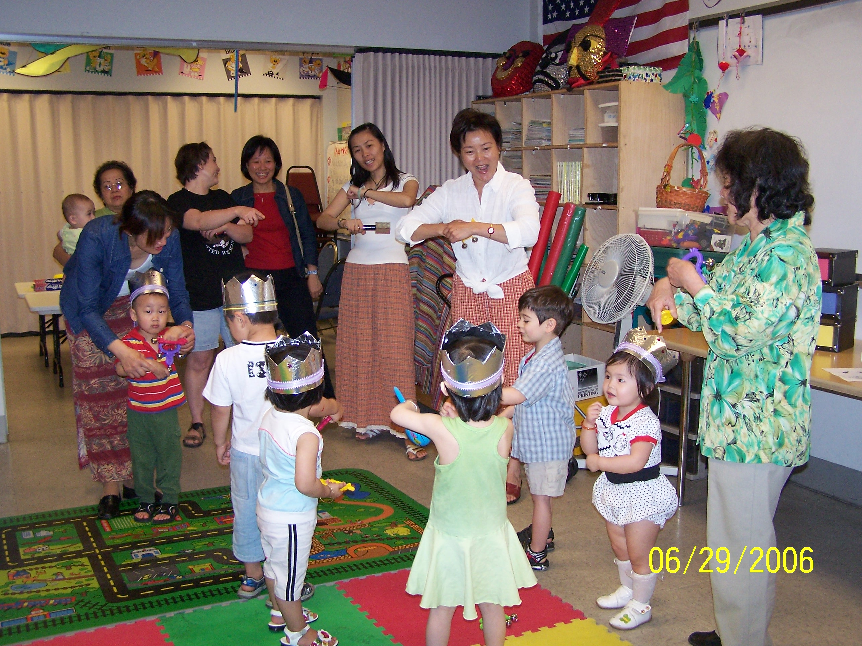
Play & Learn groups have a choice time, where children and their caregivers choose from a variety of activities such as arts projects, playing with blocks, play dough and other childhood favorites which support learning and creativity. Most groups have a circle time, where everyone gathers to sing songs, play a game, read a story or participate in an activity together.

During the group, the facilitator is active in helping children and adults engage in the activities and in providing a positive role model for interacting with children. The facilitator also checks in with the adults and provides them with information about community resources, child development and other topics. Some groups have a time when the adults are away from the children to talk and learn.

Play & Learn groups in King County do not follow a single curriculum. Some do follow or borrow from curricula of their choosing, while others build their curriculum based on the unique needs of their group.

Funding
There is no single source of funding for Play & Learn. Organizations fund their Play & Learn groups through grants and donations; many have in-kind support (eg, free space, supplies, outreach support, etc.) from community partners. Child Care Resources does have limited funds to help with the start-up of new Play & Learn groups.

The Play & Learn Network?
Child Care Resources coordinates the Play & Learn Network which is comprised of organizations offering Play & Learn groups as well as other community partners, such as libraries, community centers, businesses, government agencies and others, who offer resources and support to Play & Learn. Currently, 16 organizations offering Play & Learn are members of the Network.

Through the Network, Child Care Resources provides a wide range of support for the Network members, including facilitator training, technical assistance in starting and running Play & Learn groups, notification of funding opportunities, promotion and publicity, evaluation, public policy advocacy and partnership brokering. Child Care Resources does not provide Play & Learn programs.

Evaluation Shows Promising Results
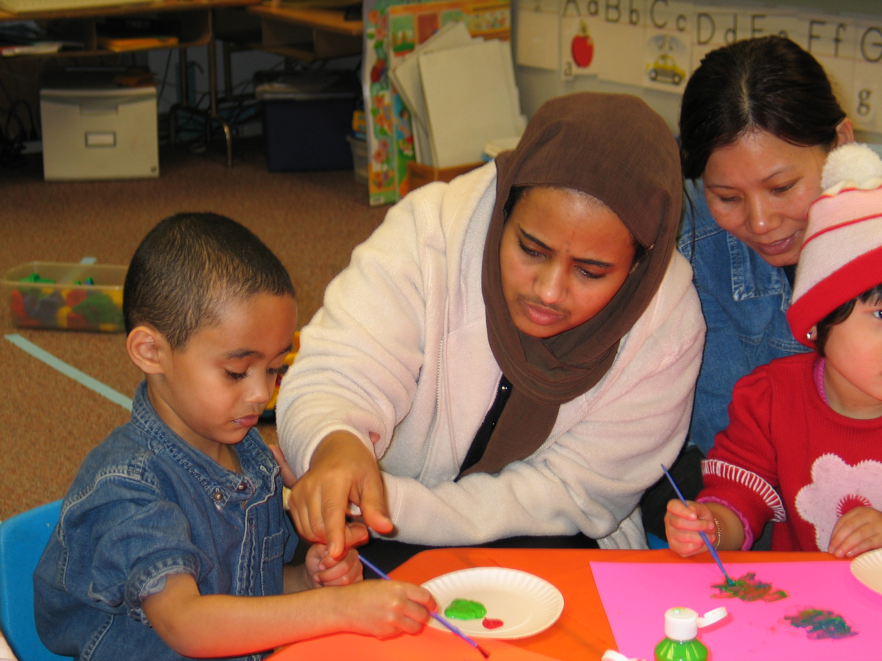
As part of the Play & Learn Network, Child Care Resources is working with Organizational Research Services and the Play & Learn Network organizations to evaluate. The evaluation includes a one-page standardized survey that participating caregivers complete. The evaluation looks at changes reported in knowledge, skills and behaviors as a result of participation in Play & Learn.

The results so far have been promising. Overall, caregivers and parents are reporting that they are learning from and using the information they receive Play & Learn groups. 72% reported increasing knowledge about their role in helping children be ready for school and 77% reported changing what they do with the children in their care “a lot more”.

The results for those participants who answered the survey in a language other than English (the survey is available in 14 languages) are even more striking. 87% reported knowing a lot more about helping kids prepare for school and understanding how children learn through play, with 92% saying they have changed their behavior because of what they’ve learned at Play & Learn.

Where to Find Out More
To find out more, please contact Lisa Conley, Play & Learn Network Coordinator at Child Care Resources at (206) 329-1011 or conley@childcare.org.

Where to Find a Play & Learn Group
Play & Learn groups are offered throughout King County by the following organizations. For specific location and schedule information, please contact the organization’s contact person.

Atlantic Street Center | Diesha Rogers, (206) 723-1301
In Rainier Beach & the Central District in Seattle. Groups for children birth to 5 years old. Groups offered in Spanish and English.
Campfire USA Central Puget Sound Council | (206) 461-8550
In Bothell. Group conducted in Spanish.
Cascade People’s Center | Myla Becker, (206) 587-0320
In SeaTac and the Central District and South Lake Union/Capitol Hill areas of Seattle. Groups offered in Spanish.
Center for Human Services | Jane Hinton, (206) 362-7282
In Shoreline, Lake Forest Park, and Bothell. Groups are offered in Korean, Spanish, Russian and English for children from birth to age 5.
Children’s Home Society | Jan Wingo, (253) 854-0700
In Auburn and Renton. Groups targeting infants and toddlers.
Chinese Information and Service Center | Hueiling Chan, (206) 624-5633, x139
Beacon Hill and the International District in Seattle and at Crossroads Shopping Center in Bellevue and the Great Wall Mall in Kent. Groups are offered in Chinese, Vietnamese and English.
Encompass | Kristina Steffen, (425) 888-2777
In Carnation and North Bend. Integrated groups including children with special needs and children who are typically developing. Targeted for children 18 months-3 years old. Groups in English and Spanish.
FamilyWorks Resource Center | (206) 694-6727
In Seattle’s Wallingford neighborhood. Groups in English and Spanish.
Greater Maple Valley Community Center | Cindy Baller, (425) 432-1272
In Maple Valley and Ravensdale. Groups for toddlers and preschoolers.
Jubilee REACH Center | Mardi Taylor, (425) 746-0506
In East Bellevue. Group in English, Japanese & Spanish.
Jugar Y Aprender | Rosa Hernandez, (425) 271-5291
In Burien. Group in English.
Neighborhood House | Saadia Hamid, (206) 816-4419
In South Seattle in Columbia City and at New Holly and Rainier Vista. Diverse members and multiple languages welcome.
North Seattle Family Center | Kaaren Sidoine, (206) 364-7930
In North Seattle.
Refugee Federation Service Center | Lan Le, (206) 762-4894
In White Center. Groups offered for multiple ages and in various languages, including English, Spanish and Vietnamese.
Refugee Women’s Alliance | Sarah Berhanu, (206) 721-8456
On Beacon Hill in Seattle. Multiple languages spoken, including English, Amharic and Tigrinya.
South Seattle Community College/APPLE Parenting | Karen Hendrickson, (206) 764-5801
In White Center and Tukwila. For parents, grandparents and other caregivers of children from birth through 18 months. Some groups offered in Spanish, Turkish, Bosnian and Russian.
Southwest Youth & Family Services | Annie Soustek, (206) 937-7680
In West Seattle. Groups in English and Spanish.
Wonderland Developmental Center | Gita Linauts, (206) 364-3777
In Shoreline. Integrated groups including children with special needs and children who are typically developing. Partnership with Center for Human Services.
September 2007

