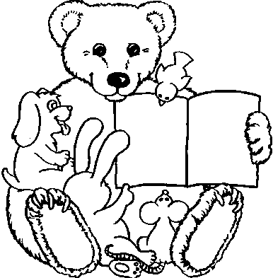
BookShare: Reaching Kids in Care ___________________________________________________________

STORYTIME STRUCTURE
To create fun and engaging storytimes, variety and flexibility are the key!
Choose stories that meet the needs of your mixed-age group. Shorter is better.
Incorporate songs/movement/fingerplays between your stories to help children get the wiggles out. Help children be successful by having the same opening and closing song or routine every time. And most of all – have FUN!
_______________________________________________________________________________

THEME: EARLY LITERACY SKILL:

Opening song / ritual:

Introduction (optional & short):

Book:

Song / Fingerplay:

Book:

Song / Movement:

Book / Flannel board:

Closing song / ritual:

