Thrilling Tales: A Story Time for Grown Ups at Your Library
Presentation at the Ontario Library Association Superconference Friday, January 30. 2009
David Wright, The Seattle Public Library Fiction Department

I. Introduction
II. “Note to Readers” from Thrilling Tales, & more tips
III. Thrilling Tales Flyers and Story Lists
IV. Sample Warm-Up Exercises
- Bibliography

I. Introduction

I premiered the Thrilling Tales adult story time at the Seattle Public Library’s central branch in March of 2004, with a reading of Jack Ritchie’s droll suspense story, The Green Heart (aka A New Leaf), which opens thus: “We had been married three months and I rather thought it was time to get rid of my wife.” The program has been going strong ever since, with twice-monthly readings of suspense and escapist short stories that draw a regular and drop-in audience of anywhere from 30 to 100 story lovers. Thrilling Tales is a lunch-hour program, and so is never longer than 45 minutes, during which time I read one or two stories, often starting with a short-short warm up story.

The program has been a lot of fun, easy to fit in among the hustle and bustle of library work, and very cheap to produce. It is also a very portable and adaptable program that can be done in a variety of ways and venues within and beyond the library’s walls. Library staff can read, or you can find talented readers in the community; many actors are very happy to give their talent to libraries and love to share. Both at the library and at conferences at which I have spoken, librarians have often come up to me and asked about this program, and so I thought it would be a good idea to work up a little presentation about this. This is the handout for that presentation, in which I offer some tips for how to read stories, a sample warm-up, a full list of the stories I’ve used in my program, and a bibliography of resources that may prove helpful in getting started.

Some types and aspects of adult story times that might work for your library’s situation or needs:

- Genres & Themes. You name it. Image a series or festival focused on: Hardboiled Crime, Hip Younger Writers, Grown Up Fairytales, Vampire Stories, Sports Stories, Dog Stories, Myths & Parables, Classics, True Crime, True Adventures & Survival, Short-short stories, Humor, Poetry, Essays, Erotica – well, maybe not erotica. You could even do (get this): Mainstream Literary Fiction!
- Longer Works: Novels are problematic for this program, as they require consistent ongoing attendance, but novellas that can be read in a few sittings may work, as well as novels of linked stories, such as Anderson’s Winesburg, Ohio or Sandra Birdsell’s Agassiz Stories.
- Story Time / Discussion: audience hears a story, and then discusses. “The World’s Easiest Book Group.”
- Knitting, Quilting, Crafting: story time accompanies a craft circle or other silent work. In general, allow audiences to knit, eat, or otherwise silently multitask.
- Frequency: Weekly, Bi-Monthly, Monthly, or a seasonal Festival of Story. (or incorporate story reading into other events or festivals). A week of scary stories in October. Outdoor story times on summer evenings.
- Exploring Cultures: a festival of stories reflecting or drawn from a particular culture. Or a series that focuses on a variety of cultures. Stories from the Yiddish. Latino Stories. Chinese Stories. Native Peoples short stories. Reading around the world.
- Combined with Storytelling. Celebrate all story: telling and reading.
- Exploring History: an event of stories from a particular era – stories from the Great Depression, or the War Years – or an ongoing series that features stories by decade, w/ historical footnotes.
- Story-and-a-movie: Reading of short stories, paired with seeing the movie based on that story. Benjamin Button, Shawshank Redemption, Field of Dreams, In the Bedroom, Minority Report, Million Dollar Baby, etc etc.
- Local Authors. Authors from your city or region, and/or set there.
- Writing & Reading: team an adult story time with a writing program, your own or one in your area. Readers or authors share stories aloud, for sensitive feedback.
- Parent & Child. Choosing materials that work for adults and older children, or for the whole family.
- Adults w/ Developmental Disabilities. There are libraries who have adapted children’s story times for outreach to these patrons.
- For Deaf patrons: story hours work well with sign interpretation.
- For Blind patrons: it’s a natural. Just make sure there’s a place for guide dogs.
- Podcasting: a great way to podcast, either live events, or record just for podcast. Public Domain, or get author permission.
- ESL & Adult Literacy: Provide stories for advance reading or reading along. Do Q & A over idiomatic questions afterwards.
- Bi-lingual story time: same story in two languages, w/ discussion.
- Outreach: great for taking to branches, senior & assisted living, vocational schools, bus stations, bars and various dens of iniquity: wherever.
- What else?: what other ideas to you have? I’d love to hear about them: david.wright@spl.org

II. “Notes to Readers” used with actor volunteers for Thrilling Tales, & more tips.

LOGISTICS:
- Readings will take place in the Microsoft Auditorium in the Central Library (1000 4th Ave) - the entrance is on the 1st floor. Readers should arrive at the auditorium no later than 11:30, where they will be met by series emcee David Wright. House ‘opens’ around 11:45, with pre-show music playing until 12:05. David will start the show with a brief introduction to our author(s) and an even briefer introduction to the reader. We hope to have most readings all done by 12:50, the end of the program cued by house coming up to full and music coming up, and readers can leave immediately after that.
- We will be leaving House Lights at half throughout the program, so people can see to eat and to exit early if they need to – please do not be disturbed by people coming and going, there may be some drop-ins and drop-outs.
- The Central Library does have a Green Room with mirror and sink, and private restrooms in a secure area of the library – David can get you access to these, and you can leave belongings there during the program. We recommend you bring your own bottled water for the event itself.
- I hope to secure funding to pay for your parking in our privately-owned library parking lot. In the meantime, we are convenient to mass transit and the bus tunnel.
- If you are unable to make a scheduled reading, it is imperative that you let David know as early as possible. This will allow me to find a replacement, or step in myself. David’s email is david.wright@spl.org, his home phone is xxxx his work phones are (206) 386-4142 and (206) 386-4660.

CONTENT:
- Stories will be chosen primarily for their entertainment value: high-interest, captivating, suspenseful, engaging, gripping stories are what we’re looking for. We will be using published stories from the Suspense and Thriller genres, with the occasional story of Detection or Horror. Humor is also welcome, the ideal program having something terrifying, and something funny. Programs may consist of a single story, or two or three short-short stories. We intend to use a single reader each day, although we may do some tandem readings, and I may help fill a too-short program with added content.
- Stories with infrequent profanity will be ‘edited for TV’ – eg. we will substitute expressions such as ‘damn’ and ‘hell’ for stronger cuss words. We will avoid stories relying on profanity or graphic sex and very graphic violence. Story selection is done by David, who will work with you to find a story you’ll enjoy sharing and provide you with a print copy suitable for reading from. Story suggestions are gratefully accepted.
- As this is a lunch-hour program, duration is very important, and the entire reading should not exceed 45 minutes. Stories will be chosen to fit the time allotment, and may be edited for length, which is far preferable to rushing the reading. David will assist with editing for profanity and length.

SOME READING TIPS YOU PROBABLY DON’T NEED:

- Don’t Rush. Or as they say in the biz: Land Your Points. If a story or stories is taking more than 45 minutes, check with David about possible cuts.
- Remember Your First Time. Your first time reading the story, that is. Did you find anything confusing, hard to follow? Take care to carry your listeners over those tough spots.
- Get an Audience. Try this out on someone, and find out if there’s anything they didn’t understand. David will always be available for this purpose.
- Casting is Everything. Remember that following dialogue read by a single person can be very challenging: help your listeners by making some clear vocal distinctions between characters in a story, using pitch, tone, pronunciation, etc. You may find it useful to mark your script to avoid crossing your voices in the middle of a reading.
- Who are you? If you are reading a story that is told in the third person (eg. not an ‘I’ story,) remember that the narrator is a character too; think about their attitudes and outlook.
- Pace yourself. Many of these stories build to a high intensity, so it is very important to get a sense of the overall arc, and avoid peaking too soon. Just as in a movie, you will find plenty of false-climaxes, sudden or gradual revelations, plot twists and surprises: work backward from these key moments. We do not expect a full-on, dramatic performance from you, but rather an articulate, fully-realized reading, so take it easy: you can do a lot with a very little.
- Speak the Speech. Re: dialect – we can work out the details of this based on the requirements of the story, and your own comfort level, but generally speaking, the hint of a dialect or accent is often sufficient. Much more important for you and the audience to have fun, than to worry about the authentic lilt of that Punjabi walk-on or Irish maid. Use Standard American for most narration: stories by British authors do not require a British accent to read, any more than you’d read deMaupassant with a French accent, or Chekhov with a Russian.
- Remember the Mike. You will be reading from a good-sized podium equipped with a light and a microphone, which means you don’t have to project, much, and can do neat things like whisper and sigh. Be sure and test levels with David on the day of the reading.

Thanks so much for your interest in this series! We’ve had lots of potential readers coming forth, and we’re only doing two of these a month, so please don’t be discouraged if it takes a while to get you a reading date. Feel free to come to me with whatever questions or suggestions you have for making this a fun, successful event!

MORE TIPS for reading and presenting a program:

- Set the Stage. Keep things simple, but have what you need: light, water, a clock, a podium or stand for your book. Pre-show music is a nice way to set the mood.
- Use a Microphone. No matter how loud you think you are, using a microphone helps those who are hard of hearing (and won’t tell you), and allows you to give a more relaxed and varied performance. Avoid headset mikes, as they don’t allow you to use the full range between screams and whispers. Check mike levels with someone else in the space.
- Rehearse. I suggest you have read a story between three and five times before sharing it with an audience. The only surprises you want during a reading are those the audience enjoys: you need to know the story and its challenges.
- Editing. It may be necessary to edit a story for length. Do so with extreme care, so as not to spoil any necessary plot elements or telling details. You probably wan to ‘edit for TV,’ or translate 21st century profanities to their 19th century counterparts.
- Mark Your Script. Do like Dickens did, and mark your story (a photocopy) with areas of special emphasis, key moments, transitions, pacing, suggestive adjectives or images, tricky pronunciations, and the like. Use colored pens to help distinguish who is speaking, when helpful.
- Also mark major breaks in the narrative flow, such as passages of time or flashbacks, and use these places to take a drink. You may also want to mark lines where you’d like to look up at the audience. When you do, be sure to keep your finger on the text; it is very easy to get lost.
- Character Voices. Ways of subtly distinguishing characters include variations in pitch, timbre, accents, pronunciation, and pacing. A little of this goes a long way.
- Character Placement. For dialogue scenes, mentally place your characters around the room, or work the sides of the microphone, to help your listeners follow along.
- Attitudes. Use strong, specific adjectives to help you be clear about a character and their intentions. Play with imaginative imagery, if you like.
- Mean What You Say. Figure out what you’re trying to say. Land your points. How do you make it real for yourself: it could be imagination alone is plenty. Or use tricks, if you need to.
- Decide who you’re talking to, as narrator or a story. Who is the narrator, and why are they telling the story? What has juts happened to precipitate this telling – what is the moment right before the story starts? Some questions to play with.
- Beware of dropping in pitch/volume at ends of sentences.
- If a story is funny, play it serious. Beware of making yourself laugh, or cry.
- Don’t comment on the story. That is, don’t comment while you’re reading it, with voice or looks. If you don’t like a story, don’t read it.
- Start slowly, and don’t rush. It is very easy to get ahead of yourself. Don’t.
- Earn your pauses. Not to say don’t pause, but do it for a reason.
- When you mess up (and you will), don’t make a big deal about it. Occasional flubs are inevitable, and as long as you don’t let them throw you, the audience won’t mind them. Correct yourself, and move on.
- Relax. Concentrate. Think. Breathe. Thought creates breath. Breath turns thoughts to speech. If you are prepared, then reading is mostly about getting out of the way and letting the story flow.
- Enjoy yourself. This is key – when you enjoy telling a story, your listeners enjoy hearing it. Relish the story’s gifts, an intriguing character, a beautiful description, a clever turn of phrase, an exciting discover. Have fun.
- Practice. On challenging texts: Charles Dickens, George Eliot, Henry James, William Faulkner. Think of it as read aloud resistance training.

IV. Thrilling Tales Flyers and Story Lists.
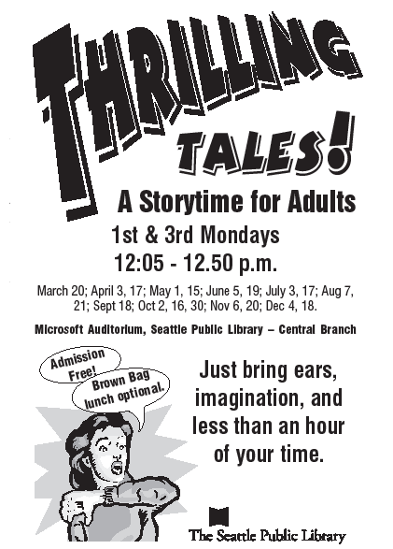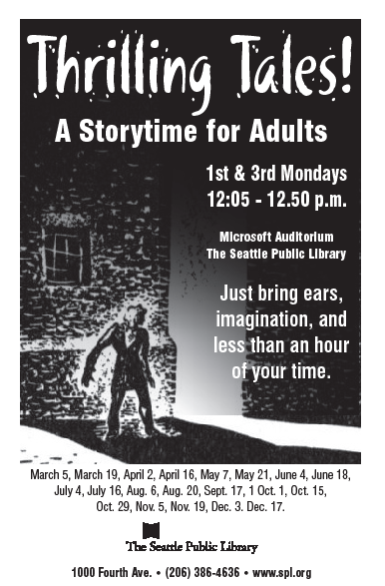
Thrilling Tales Story List, 2005 - 2007
2005
3/21 David Wright A New Leaf, by Jack Ritchie
4/4 Nancy Pearl It’s Bad Luck to Die, by Elizabeth McKracken
4/18 G Douma Without Jonathan, by Jeffrey Deaver
5/2 David Wright The Weekender, by Jeffrey Deaver
5/16 M Waldstein The Most Dangerous Game, by Richard Connell
6/6 L Montez Maniac Loose, by Michael Malone
6/20 David Wright The Theatre, by Bentley Little
7/18 David Wright The Absence of Emily, by Jack Ritchie
8/1 S Poncey The Girl with the Blackened Eye, by Joyce Carol Oates
8/15 David Wright Too Many Crooks, by Donald Westlake
8/29 J Goldstein The Fall Guy, by Jeffery Deaver
9/19 David Wright The Way Up to Heaven, by Roald Dahl. Nothing but Bad News, Henry Slesak
10/3 David Wright The Heart is a Determined Hunter, by Th Smith. Summerland, by AvramDavidson.
10/17 David Wright WS,by L P Hartley The Boarded Window, by Ambrose Bierce
10/31 David Wright Swamp Horror. The Tiger, by Stephen King
11/7 R White The Child by Roddy Doyle.
11/21 David Wright The Problem of Li T’ang, by Geoffrey
12/5 R Pate Fat Man, by Isak Dinesen. The Black Ooze, by
12/19 David Wright Christmas is a Sad Season for the Poor, by John Cheever

2006
1/2 David Wright Happiness Before Death, by Henry Slesar. Sredni Vashtar, by Saki
1/30 S Yates People Across the Canyon, by Marcia Muller
2/6 K Hsieh Smash & Grab, by Michael Knight
3/20 David Wright The Plunge, by David Goodis.
4/3 David Wright Quitters, Inc, by Stephen King
4/17 David Wright Dead Man’s Head, by Robert Leslie Bellem
5/1 David Wright Triangle, by Jeffrey Deaver
5/15 David Wright The Hobby, by Erik McCormack, The Witch, by Shirley Jackson, The Town Where No
One Got Off, by Ray Bradbury.
6/5 David Wright The Banshee, by Joyce Carol Oates.
6/19 David Wright Guilt, by John Jakes. Fatherly Love, by Carl Martin

Monday, July 3. If you’d been reading Mademoiselle magazine in June of 1945, you might have happened upon this uncanny short story by an unknown young writer with an odd sounding name. After reading Miriam, as the chills wore off and your pulse rate returned to normal, you might have made a mental note, that this Truman Capote fellow was someone to watch out for.

Monday, July 17. Hated, by Christopher Fowler. A strange encounter leads golden boy Michael Townshend to discover the cloud inside his silver lining. It couldn’t happen to a nicer guy, but maybe that’s the point - the nicer they are, the harder they fall.

Monday, August 7. Suspicion, by Dorothy Sayers. When an arsenic poisoner is on the loose, those hearty English breakfasts don’t sit quite so well, in this twisted tale worthy of Hitchcock, from the grand dame of British mystery.

Monday, August 21. Raising Cain! Two classic crime stories by two of the toughest tough guy writers of the 1930s. James M. Cain heats things up with his sultry noir, Brush Fire, and the enigmatic Paul Cain cools them down again with his lean, mean caper, Black. No minute eggs here: these guys are hardboiled.

Monday, September 18. The Baby-Sitters, by Alex Hamilton. Finding a good sitter for the children can be such a bother, but party-bound parents Muriel and Selwyn have lighted on the perfect solution. Perhaps too perfect.

Monday, October 2. The Screaming Woman, by Ray Bradbury. Ten-year-old Margaret says she can hear someone buried alive in the backyard. Oh these children and their imaginary friends – what will they think up next!

Monday, October 16. Lost Hearts, by M.R. James. When orphaned young Stephen Elliot is taken in by his elderly cousin, he little suspects that murdering spirits will be the least of his worries. Montague Rhodes James was a great master of the gothic ghost story. Also, the wry Uninvited Ghosts, by Penelope Lively.

Monday, October 30. The Inexperienced Ghost, by H.G. Wells. Charming and chilling, this curious tale of a hapless spirit caught on the wrong astral plane is one of the strangest ghost stories ever told.

Monday, November 6. A Genuine Alectryomancer, by Charles Willeford. What is an Alectryomancer? You could look it up. Or better yet, come to the library, to hear a great American crime writer’s extraordinary account of ominous rites and direful deeds performed under a tropic moon.

Monday, November 20. A Home Away from Home, by Robert Bloch. A great author of weird stories, Bloch is perhaps best known for a little book entitled Psycho. Mr. Loveday’s Little Outing, by Evelyn Waugh. You’d probably want to go day-trippng too, if you lived in an insane asylum!

Monday, December 4. Button, Button, by Richard Matheson. Nora and Arthur Lewis receive a package bearing a postmark from the Twilight Zone. A Gentlemen’s Agreement, by Lawrence Block. The ever-resourceful Arthur Trebizond turns the tables on a burglar. Two classic stories that turn and turn again.

Monday, December 18. Not a Laughing Matter, by Evan Hunter. A has-been actor prepares for the role of his life, or his death. A Visit to the Bank, by Shirley Jackson. He sees you when you’re sleeping, he knows when you’re awake, and he’s got a pretty good idea of your credit rating.

2007
Monday, March 5 Vengeance is Mine, Inc. by Roald Dahl.
Ever been so mad you’d like to punch someone in the nose? How about dropping a rattlesnake in their car? Just give George and Claude a call; they're very resourceful. Guest reader M McNelis.

Monday, March 19. The Baby in the Icebox, by James M. Cain.
You’ve heard of the Lady or the Tiger? How about the Lady AND the Tiger? In the tradition of his The Postman Always Rings Twice and Double Indemnity, American master Cain tells a sultry tale of dirty dealings at a roadside gas station where a femme fatale and a ferocious feline match claws. Note: Today’s Thrilling Tales will be in Conference Room 1, Level 4.

Monday, April 2 - The Nose, by Nikolai Gogol.
One morning a supercilious bureaucrat wakes up to find his nose has vanished, but that’s almost normal compared to what happens next! Step into this great 19th-century Russian author’s version of The Twilight Zone. Gogol’s strange tale will be podcast in honor of the 2007 Seattle Reads selection, The Namesake.

Monday, April 16 - Tick, Tock, by Donald Wandrei.
Wandrei really stacks the deck in this 1938 tale from Black Mask magazine, when he shows us a disgruntled employee sending a surprise birthday package to his boss, with a little girl as messenger. Alfred Hitchcock loved it, and so will you.

Monday, May 7 - The Cistern, by Ray Bradbury.
Rain, rain, go away, but where does it go when it flows away? Little Anna knows where it goes, to a secret city beneath the streets, where ghastly surprises lurk. Also English Autumn, American Fall, by Minette Walters.

Monday, May 21 - Strangers in the Fog, by Bill Pronzini.
Hannigan just finished digging the grave when the dark shape of a man came out of the fog. Here’s a tense drama with all the eerie chills of old time radio. Also, Package Deal, by Jack Ritchie. A bank teller has difficulties when he tries to take his work home with him.

Monday, June 4 - The Moment of Decision, by Stanley Ellin
Good fences may make good neighbors, but no fence could restrain the hatred building between know-it-all Hugh Lozier and the magician next door. This masterpiece of psychological suspense has an indescribable climax.

Monday, June 18 - After You’ve Gone, by John Peyton Cooke
A man at the end of his tether gets a lot more than he bargained for when he calls a suicide help line.

Monday, July 2. The Commuter, by Jeffrey Deaver.
This story is dedicated to everyone who has every been bothered by that loud, obnoxious person talking on their cell phone, from a modern master of suspense whose middle name could be ‘when-you-least-expect-it.’

Monday, July 16 Anyone for Murder? by Jack Ritchie.
A man takes out a classified ad in the paper, offering unhappy spouses the ‘ultimate solution’ to their marital problems. In addition to this wry tale of husbandry and homicide, we will also have Ritchie’s short-short, #8. Hitchhiking can be dangerous, but for whom?

Monday, July 30. A Curious Suicide, by Patricia Highsmith.
As in her famous story ‘Strangers on a Train,’ homicide is hatched on the rails, and a mild-mannered man struggles to find the evil within himself. Also The Landlady, by Roald Dahl. A young boarder finds a cozy spot where he can finally rest.

Monday, August 6 Little Paradise, by Zena Collier. Vacationing boaters get away from it all, and leave civilization behind, to their eventual terror. Also, The Radio, by Davis Grubb. When the mercury soars and the air conditioner breaks down, it seems as though machines are out to get us. A great mid-century tale of mechanical paranoia by the author of Night of the Hunter.

Monday, August 20 A Corner of Paradise, by Stanley Ellin. They tried to tell him that the big city was a jungle, but old Mr. Hotchkiss has a green thumb, and he’s out to make it a garden of Eden, if the serpents don’t get him first, that is.

Monday, Sept. 17 The Hanged Man, by Ian Rankin. The premiere Scottish mystery writer tells of a killer who goes to a fortune teller to find out whose Death is in the cards. Also A Humanist, by Romain Gary; a profoundly horrifying tale without a single drop of blood or unkind word.

Monday, Oct. 1 The Box, by Jack Ketchum. “What’s in the box?” my son said. It turns out there was nothing in the box – a nothing worse than any something you could imagine. Also a classic weird tale: The Ninth Skeleton, by Clarke Ashton Smith.

Monday, Oct. 15 The Nature of the Thing, by Patricia Highsmith. Eleanor is living alone with her cat and her knitting, when a little two-foot tall goblin man takes up residence in her house. Only Highsmith’s disconcerting genius could envision the relationship that ensues.

Monday, Oct. 29 Ghost Stories for Hallowe’en. Join us for a lunch hour to raise your spirits. Long Distance Call, by Richard Matheson.

Monday, November 5: Wedding in Voerde, by Gunter Gerlach, translated by Mary Tannert. Here’s an hilarious caper about two hapless ex-cons attending their old pal Heinz’s wedding in search of hidden loot, from Germany’s answer to Elmore Leonard, one of several great international crime writers whose Thrilling Tales will be featured in the months to come.

Monday, November 19: Sinkhole, by Carol Cail. Its bad enough to know your marriage is on the rocks, but when your secret affair leads you to a hole in the ground, there’s no telling what will happen. Macabre fun in the Hitchock tradition.

Monday, December 3. Improvisation, by Ed McBain. “Why don’t we kill somebody?” Was it just a highly original pick-up line, or was she serious? A terrific suspense tale from the late lamented master of crime.

Monday, December 17. Mr. Huffam, by Hugh Walpole. Here’s a ghostly tale of cheer to warm your Holiday heart.

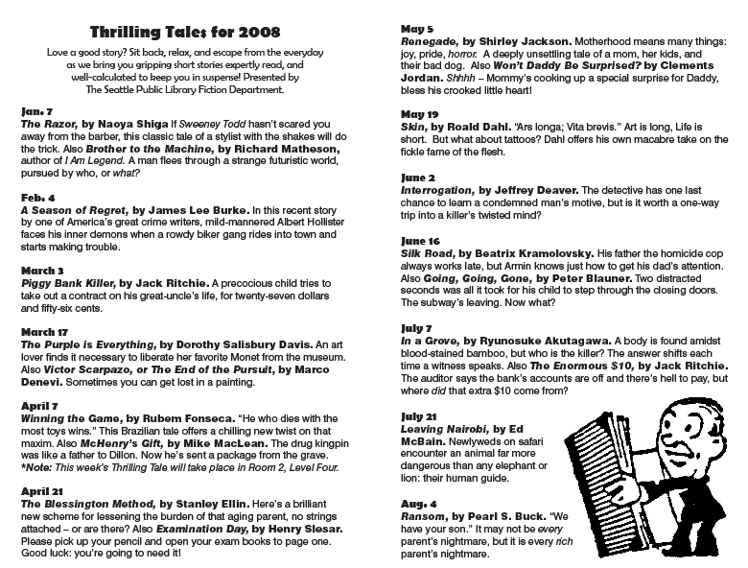

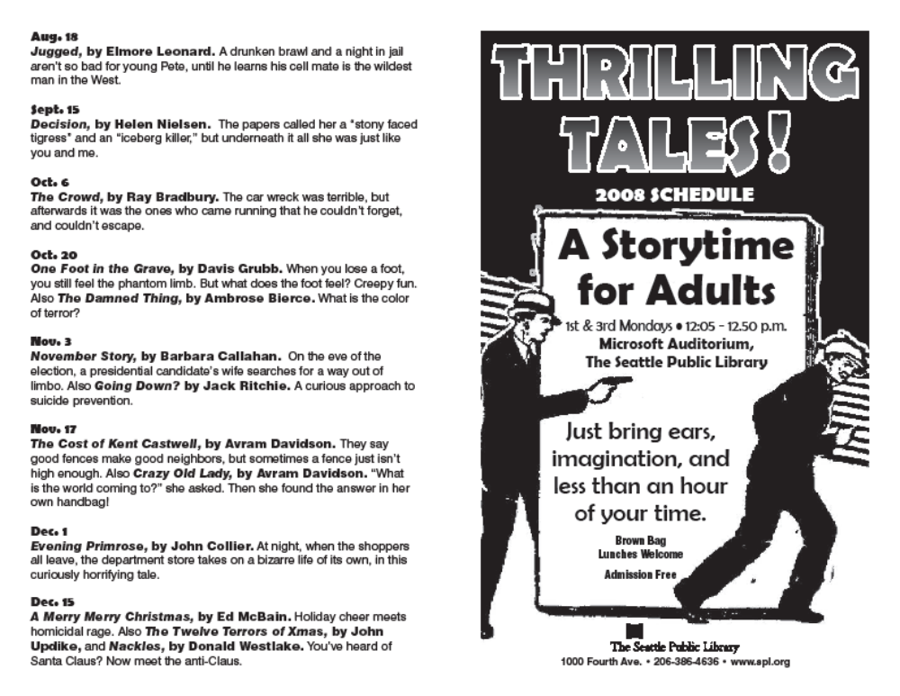

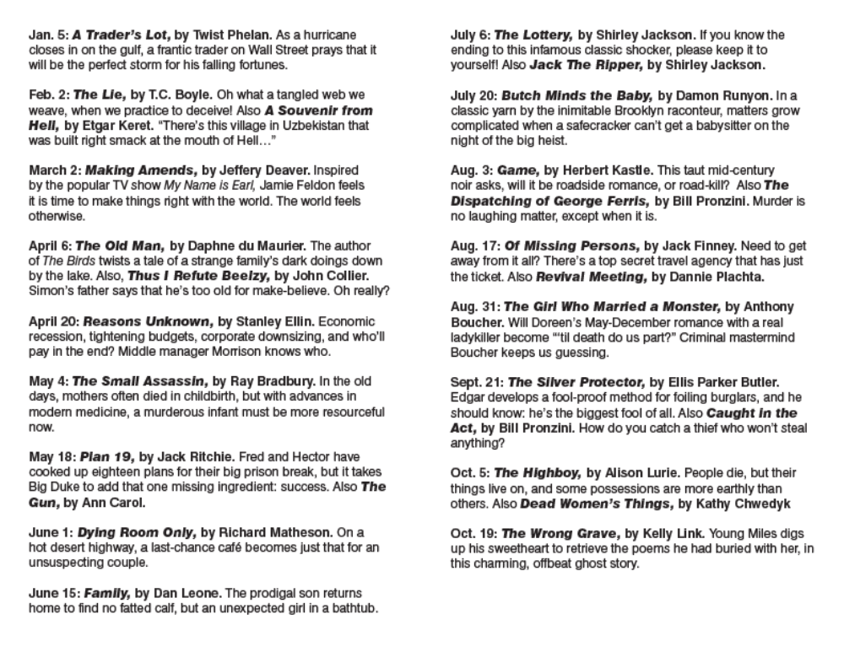
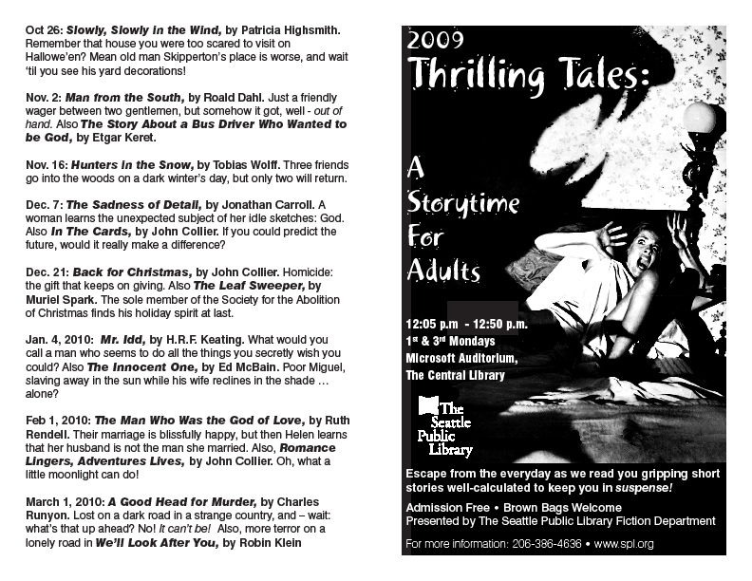

V. Sample Warm Up Exercises

If you’re going to read stories to patrons in your library, it is a good idea to do some vocal and physical warming up before you read. It will make your voice more flexible and responsive to the demands of the story, and is a useful ritual to help you focus on the task at hand, and to relax and enjoy the story. The bibliography just below has a number of good books on voice, but here are some sample exercises.

  - If you already do Yoga, that is a great thing to do prior to your story.
  - Doing this stuff in the shower is great – steam for your voice, great echo.
  - Jog in place for a minute, feeling the breath in your body and letting go of tension.
  - Do a few stretches: arms over your head and inhale, to the side, twisting the body. Breathe deeply, hold your breath for 5 seconds and then let it out with an audible ‘ah.’
  - In general as you warm up, do these three things: HUM – mmmm, nnnnn, ngngng – humming is develop your resonance and relax your voice. YAWN – wonderfully relaxing for the face, soft palate and throat, oxygenates your brain. SIGH – relax and release. Try a YAWN-SIGH – yawn and sigh from your very highest note to your very lowest.
  - Tense and release: standing or lying, tense up every part of your body and hold for 10 seconds. Release and relax.
  - Let your body hang forward from the waist like a rag doll. Gradually roll up your spine to a standing position. Hum as you go, working up and down from high to low.
  - Stretch your face: Pretend you’re chewing a giant wad of bubble gum, make the biggest face you can, the smallest face you can, stick out your tongue, making sound. Blow air out your lips with sound: make a fool of yourself.
  - Run through some sounds, and exaggerate them to warm up your articulation: Bee Bee Bee Baa Baa Baa Mee Maa Mee Maa Tee Taa Gee Gaa zzzzz vvvvv etc. Try some tongue twisters.

In General: get plenty of sleep before you do a reading. Drink lots of water, but don’t overdo the coffee on a reading day, and avoid alcohol and milk products before a reading. Be prepared. Love your audience: make eye contact, smile, and enjoy being with them and sharing your story. Or pretend to.

V. BIBLIOGRAPHY

READING, VOICE & ACTING
Alburger, James R.The art of voice acting : the craft and business of performing for voice-over. Focal Press, c2002
Berry, Cicely. The actor and his text. Scribner, 1988, c1987.
Berry, Cicely. Voice and the actor. Macmillan, 1974, c1973.
Blumenfeld, Robert Acting with the voice : the art of recording books Limelight Editions, 2004
Blumenfeld, Robert Accents : a manual for actors Limelight Editions, 2002
Chekhov, Michael To the actor; on the technique of acting. Harper [c1953]
Kahle, Peter V. T. Naked at the podium : the writer's guide to successful readings : how to use drama as a tool to give dynamic readings anywhere. 74th Street Productions, c2001.
Linklater, Kristin. Freeing the natural voice. Drama Book Specialists, c1976.
Linklater, Kristin. Freeing the natural voice : imagery and art in the practice of voice and language Nick Hern, 2006

PODCASTING & PERMISSION
Stim, Richard. Getting permission : how to license & clear copyrighted materials online and off. Nolo, c2007.
Morris, Tee. Podcasting for dummies. Wiley, c2008.
Geoghegan, Michael W. (Michael Woodland), 1968. Podcast solutions : the complete guide to audio and video podcasting. Friends of Ed c2007.
Holtz, Shel. How to do everything with podcasting. McGraw-Hill, c2007.
Mack, Steve. Podcasting bible. Wiley, c2007.
SHORT STORY REFERENCE
Cook, Dorothy Elizabeth Short story index; an index to 60,000 stories in 4,320 collections. H. W. Wilson, 1953.
Magill, Frank Northen Short story writers. Salem Press, c1997.
Thomson Gale (Firm). LitFinder. Thomson Gale
Hooper, Brad. The Short Story Readers’ Advisory. ALA Editions, 2000.
Emmens, Carol A. Short stories on film and video. Libraries Unlimited, 1985.
Prose, Francine. On writing short stories. Oxford University Press, 2000.
Smith, Patrick A. Thematic guide to popular short stories. Greenwood Press, 2002.
Watson, Noelle. Reference guide to short fiction. St. James Press, c1994.
White, Ray Lewis. Index to Best American short stories and O. Henry prize stories. G.K. Hall, c1988.
Gelfant, Blanche H. The Columbia companion to the twentieth-century American short story. Columbia University Press, 2000.
Werlock, Abby H. P. The Facts on File companion to the American short story. Facts on File, c2000.
Weaver, Gordon. The American short story, 1945-1980 : a critical history. Twayne, 1983.
Stevick, Philip. The American short story, 1900-1945 : a critical history. Twayne Publishers, 1984.
Current-García, Eugene. The American short story before 1850 : a critical history. Twayne Publishers, 1985.
West, Ray Benedict, The short story in America, 1900-1950. H. Regnery Co., 1952.
Yancy, Preston M. The Afro-American short story : a comprehensive, annotated index with selected commentaries. Greenwood Press, 1986.

SOME ANTHOLOGIES
The O. Henry prize stories. Anchor Books, c2003-
The best American short stories ... and the yearbook of the American short story. Houghton Mifflin Co., 1942-1977
Best new American voices. Harcourt, c2000-
Ford, Richard The new Granta book of the American short story. Granta, 2007.
Henderson, Bill The Pushcart book of short stories : the best short stories from a quarter-century of the Pushcart prize. Pushcart Press ; Distributed by W.W. Norton & Co., c2002.
Pritchett, V. S. (Victor Sawdon). The Oxford book of short stories. Oxford University Press, 2001.
Oates, Joyce Carol The Ecco anthology of contemporary American short fiction. HarperCollins, c2008.
Marcus, Ben. The Anchor book of new American short stories. Anchor Books, 2004.
Updike, John. The best American short stories of the century. Houghton Mifflin, c1999.
Scribner's best of the fiction workshops. Scribner Paperback Fiction, c1997-
Fallaize, Elizabeth. The Oxford book of French short stories. Oxford University Press, 2002.
Carver, Raymond. American short story masterpieces. Delacorte Press, c1987.
------------------------------------------------------------------------------------------
Atwood, Margaret Eleanor The Oxford book of Canadian short stories in English. Oxford University Press, 1986.
Atwood, Margaret Eleanor The new Oxford book of Canadian short stories in English. Oxford University Press, 1995.
Becker, May Lamberton Golden tales of Canada. Dodd, Mead & company, 1938.
Black, Ayanna. Fiery spirits : a collection of short fiction and poetry by Canadian authors of African descent. HarperCollins, c1994.
Doctorow, Cory. Tesseracts eleven : amazing Canadian speculative fiction. Edge Science Fiction and Fantasy
Gerson, Carole, Vancouver short stories. University of British Columbia Press, 1985.
Lucas, Alec. Great Canadian short stories; an anthology. Dell Pub. Co.] c1971.
Martin, Wendy, We are the stories we tell : the best short stories by North American women since 1945. Pantheon Books, c1990.
Martin, Wendy More stories we tell : the best contemporary short stories by North American women. Pantheon Books, c2004.
Ondaatje, Michael, From Ink Lake : Canadian stories. Viking, 1990.
Sullivan, Rosemary. The Oxford book of stories by Canadian women in English. Oxford University Press, 1999.
Teleky, Richard. The Oxford book of French-Canadian short stories. Oxford University Press, 1983.
Whitaker, Muriel A. The best Canadian animal stories : classic tales by master storytellers. McClelland & Stewart, c1997.
Williford, Lex The Scribner anthology of contemporary short fiction : fifty North American stories since 1970. Simon & Schuster, c1999.
------------------------------------------------------------------------------------------
Asimov, Isaac. 100 malicious little mysteries Sterling Pub., 1981
Sarraontinio, Al. 100 hair-raising little horror stories Sterling Pub., 2003
Dziemianowicz, Stefan. 100 astounding little alien stories Barnes & Noble Books, 1996
Dziemianowicz, Stefan. 100 creepy little creatures Barnes & Noble,
Dziemianowicz, Stefan. 100 crooked little crime stories Sterling Pub. 1994
Dziemianowicz, Stefan. 100 dastardly little detective stories Sterling Pub., 2003
Dziemianowicz, Stefan. 100 fiendish little frightmares Barnes & Noble Books, 1997
Dziemianowicz, Stefan. 100 ghastly little ghost stories Barnes & Noble Books, 1997
Dziemianowicz, Stefan. 100 hilarious little howlers Barnes & Noble Books, 1999
Dziemianowicz, Stefan. 100 menacing little murder stories Barnes & Noble Books, 1998 13
Dziemianowicz, Stefan. 100 sneaky little sleuth stories Barnes & Noble Books, 1997
Dziemianowicz, Stefan. 100 tiny tales of terror Barnes & Noble, 1996
Dziemianowicz, Stefan. 100 twisted little tales of torment Barnes & Noble, 1998
Dziemianowicz, Stefan. 100 vicious little vampire stories. Barnes & Noble Books, 1995
Dziemianowicz, Stefan 100 wicked little witch stories. Sterling Publishing Co., Inc., 2003, c1995.
Dziemianowicz, Stefan. 100 wild little weird tales. Barnes and Noble, 1994
Dziemianowicz, Stefan. Horrors! : 365 scary stories Barnes & Noble Books, 1998
MacDonald, Margaret Read Three-minute tales : stories from around the world to tell or read when time is short. August House Publishers, 2004.
Shapard, Robert New sudden fiction : short-short stories from America and beyond. W.W. Norton, c2007.
Thomas, James Flash fiction forward : 80 very short stories. W.W. Norton & Co., c2006.
------------------------------------------------------------------------------------------
Hoch, Edward D.The Year's best mystery & suspense stories. Walker, 1982-
Best detective stories of the year. E.P. Dutton.
Mystery scene. The year's 25 finest crime and mystery stories. Carrol & Graf, 1992-
Hutchings, Janet. Passport to crime : the finest mystery stories from international crime writers. Carroll & Graf, c2007.
Slung, Michele B.Murder & other acts of literature : twenty-four unforgettable and chilling stories by some of the world's best-loved, most celebrated writers. St. Martin's Press, 1997.
Manhattan noir 2 : the classics. Akashic Books, c2008.
Penzler, Otto. The vicious circle : mystery and crime stories by members of the Algonquin Round Table. Pegasus Books, 2007.
Phillips, Gary. Politics noir : dark tales from the corridors of power. Verso, 2008.
Child, Lee. Killer year : stories to die for-- from the hottest new crime writers. St. Martin's Minotaur, 2008.
Penzler, Otto. Uncertain endings : the world's greatest unsolved mystery stories. Pegasus Books : Distributed by Consortium, 2006.
Dickens, Charles, Hunted down : the detective stories of Charles Dickens. Peter Owen ; Distributed in the USA by Dufour Editions Inc. c1996.
Landrigan, Linda. Alfred Hitchcock's mystery magazine presents fifty years of crime and suspense. Pegasus Books, 2006.
Coben, Harlan, Mystery Writers of America presents Death do us part : new stories about love, lust, and murder. Little, Brown, 2006.
Coleman, Reed Farrel Hard boiled Brooklyn. Bleak House Books, c2006.
Twin cities noir. Akashic ; Turnaround [distributor], c2006.
Brett, Simon. The detection collection. St. Martin's Minotaur, 2006.
Gorman, Edward. The adventure of the missing detective : and 19 of the year's finest crime and mystery stories! Carroll & Graf Publishers, c2005.
McBain, Ed. Transgressions. Forge, 2005.
Penzler, Otto. Dangerous women. Mysterious Press, c2005.
Jakubowski, Maxim. The best British mysteries 2005. Allison & Busby, 2004.
Gorman, Edward. The world's finest mystery and crime stories. Fifth annual collection. Forge, 2004.
George, Elizabeth. A moment on the edge : 100 years of crime stories by women. HarperCollins, [2004]
Browning, Abigail. Murder is no mitzvah. Thomas Dunne Books/St. Martin's Minotaur, 2004.
Westlake, Donald E. Thieves' dozen. Mysterious Press, c2004.
Penzler, Otto. The 50 greatest mysteries of all time. Phoenix Books, c2003.
Edwards, Martin Mysterious pleasures : a celebration of the Crime Writers' Association's 50th anniversary. Little, Brown, 2003.
Deaver, Jeffery. Twisted : the collected stories of Jeffery Deaver. Simon & Schuster, c2003.
Bloch, Robert Crimes and punishments. Subterranean Press, 2002.
Sayers, Dorothy L. (Dorothy Leigh) The complete stories. Perennial, c2002.
Gorman, Edward. The world's finest mystery and crime stories : third annual collection. Forge, 2002.
Jefferies, William A century of great suspense stories. Berkley Prime Crime, 2001.
Mystery Writers of America presents In the shadow of the master : classic tales. William Morrow, c2009.
Schechter, Harold. True crime : an American anthology. Library of America, c2008.
------------------------------------------------------------------------------------------
Winter's tales. St. Martin's Press, c1985-
The Graywolf annual. Graywolf Press, 1985-
Story (New York, N.Y. : 1967-). Story. Story Magazine, Inc.
Jarrell, Randall, Randall Jarrell's book of stories : an anthology. New York Review Books ; Distributed by Publishers Group West, [2002]
Deitz, Paula. Writes of passage : coming-of-age stories and memoirs from The Hudson review. Ivan R. Dee, Publisher, c2008.
Burmeister-Brown, Susan. Mother knows : 24 tales of motherhood. Washington Square Press, 2004.
Gable, Craig, Ebony rising : short fiction of the greater Harlem Renaissance era. Indiana University Press, c2004.
Broussard, Meredith. The dictionary of failed relationships : 26 tales of love gone wrong. Three Rivers Press, c2003.
Max, B. Delores. Dumped : an anthology. Grove Press, c2003.
Kihn, Greg. Carved in rock : short stories by musicians. Thunder's Mouth Press, c2003.
Chabon, Michael. McSweeney's mammoth treasury of thrilling tales. Vintage Books, 2003.
Chabon, Michael. McSweeney's enchanted chamber of astonishing stories. Vintage Books, 2004.
Howe, James. The color of absence : 12 stories about loss and hope. Simon Pulse, 2003.
Schroeder, Anne. Scent of cedars. Russell Dean & Co., c2002.
Estleman, Loren D. American West : twenty new stories. Forge, 2001.
Hornby, Nick. Speaking with the angel. Riverhead Books, 2001.
Datlow, Ellen. Salon fantastique : fifteen original tales of fantasy. Thunder's Mouth Press, c2006.
Klima, John. Logorrhea : good words make good stories. Bantam Books, 2007.
Merrick, Elizabeth. This is not chick lit : original stories by America's best women writers. Random House Trade Paperbacks, c2006.
Coles, Robert. Teaching stories : an anthology on the power of learning and literature. Modern Library, c2004.
Morrison, Rusty. ParaSpheres : extending beyond the spheres of literary and genre fiction : fabulist and new wave fabulist stories. Omnidawn Pub., 2006.
Prasad, Chandra. Mixed : an anthology of short fiction on the multiracial experience. W.W. Norton & Co., c2006.
Mandelbaum, Paul. 12 short stories and their making. Persea Books, c2005.
McSweeney's. The Better of McSweeney's. Volume one, Issues 1-10. McSweeney's Books, [2005?]
Sedaris, David. Children playing before a statue of Hercules. Simon & Schuster, 2005.
Selvadurai, Shyam,. Story-Wallah : a celebration of South Asian fiction. Houghton Mifflin, 2005.
Harrison, Stephanie. Adaptations : from short story to big screen : 35 great stories that have inspired great films. Three Rivers Press, c2005.
Slung, Michele B. The garden of reading : an anthology of twentieth-century short fiction about gardens and gardeners. Overlook Press, 2005.
Rosenthal, Lucy. The eloquent short story : varieties of narration : an anthology. Persea Books, c2004.
Kaldas, Pauline Dinarzad's children : an anthology of contemporary Arab American fiction. University of Arkansas Press, 2004.
Bierlein, Stacy A stranger among us : stories of cross cultural collision and connection. OV Books, c2007.
Eggers, Dave. The best American nonrequired reading 2008. Houghton Mifflin, 2008.
Hartwell, David G. Year's best fantasy. 8. Tachyon, 2008.
------------------------------------------------------------------------------------------
Poe, Edgar Allan,The raven and the monkey's paw : classics of horror and suspense from the Modern Library. Modern Library, 1998.
Howard, Robert Ervin,. The horror stories of Robert E. Howard. Del Rey, 2008.
Betancourt, John. Horror : the best of the year. Prime Books, c2006.
Jones, Stephen, The mammoth book of best new horror. Volume fifteen. Carroll & Graf, 2004.
Duane, Kit,The Campfire collection : ghosts, beasts, and things that go bump in the night. Chronicle Books, 2003.
Pockell, Leslie. The 13 best horror stories of all time. Warner Books, c2002
Kessler, Joan. Night shadows : twentieth-century stories of the uncanny. David R. Godine, Publisher, 2001
Chekhov, Anton Pavlovich, Night in the cemetery : and other stories of crime & suspense. Pegasus Books, 2008.
On a raven's wing : new tales in honor of Edgar Allan Poe. Harper, c2009.
Ruber, Peter A. Arkham's masters of horror : a 60th anniversary athohology retrospective of the first 30 years of Arkham House. Arkham House Publishers, 2000.
Leiber, Fritz Dark ladies. Orb, 1999, c1991.
Wagner, Phyllis Cerf, Great tales of terror and the supernatural. Modern Library, c1994.
Anderson, Kevin J. The Horror Writers Association presents Blood lite : an anthology of humorous horror stories. Pocket Books, 2008.
Slung, Michele B. Murder for Halloween : tales of suspense. Mysterious Press, c1994.
Chetwynd-Hayes, R. (Ronald). Tales to freeze the blood. Carroll Graf Publishers, 2006.
Haining, Peter. The mammoth book of haunted house stories. Carroll & Graf, 2005.
Datlow, Ellen. The dark : new ghost stories. Tor, 2003.
Cox, Michael The Oxford book of English ghost stories. Oxford University Press, [2002], c1986.
James, M. R. Casting the runes and other ghost stories. Oxford University Press, c2002.
Gorey, Edward, The haunted looking glass : ghost stories. New York Review Books, [2001], c1959.
Weingarten, Roger. Ghost writing : haunted tales by contemporary writers. Invisible Cities Press, c2000.
SOME COLLECTIONS
Bierce, Ambrose The complete short stories of Ambrose Bierce. University of Nebraska Press, [1984], c1970.
Borges, Jorge Luis Labyrinths : selected stories & other writings. New Directions, 2007.
Boyle, T. Coraghessan. T.C. Boyle stories : the collected stories of T. Coraghessan Boyle. Viking, 1998.
Bradbury, Ray, The October country. Avon Books, 1999.
Bradbury, Ray. Bradbury stories : 100 of his most celebrated tales. William Morrow, c2003.
Capote, Truman The complete stories of Truman Capote. Vintage International, 2005.
Carver, Raymond. Where I'm calling from : new and selected stories. Vintage Books, 1989.
Chekhov, Anton Pavlovich, Stories. Bantam Books, 2000.
Collier, John. Fancies and goodnights. New York Review Books, c2003.
Cheever, John. The stories of John Cheever. Vintage International, 2000, c1947.
Dahl, Roald. Roald Dahl's tales of the unexpected. Vintage Books, 1990.
Eisenberg, Deborah. Twilight of the superheroes. Farrar, Straus and Giroux, 2006.
Ellin, Stanley. The specialty of the house and other stories : the complete mystery tales, 1948-1978. Mysterious Press, 1979.
Gallant, Mavis. The collected stories of Mavis Gallant. Random House, c1996.
Henry, O. The best short stories of O. Henry. Modern library, 1994, c1945.
Highsmith, Patricia The selected stories of Patricia Highsmith. Norton, c2001.
Jackson, Shirley The lottery and other stories. Farrar, Straus and Giroux, 1982, c1949.
King, Stephen. Nightmares & dreamscapes. Viking, 1993.
Link, Kelly. Pretty monsters : stories. Viking, 2008.
Mansfield, Katherine The short stories of Katherine Mansfield. Ecco Press, 1983, c1937.
Matheson, Richard, Duel : terror stories. Tor, 2003.
Matheson, Richard, Nightmare at 20,000 feet : horror stories. Tor, c2002.
McCracken, Elizabeth. Here's your hat what's your hurry : stories. Turtle Bay Books, 1993.
McCullers, Carson. Collected stories : including The member of the wedding and The ballad of the sad café. Houghton Mifflin, 1998.
Moore, Lorrie. Birds of America : stories. A. Knopf, 1998.
Munro, Alice. Carried away : a selection of stories. Alfred A. Knopf, c2006.
Oates, Joyce Carol The collector of hearts : new tales of the grotesque. Thorndike Press, c1998.
O'Connor, Flannery. The complete stories. Farrar, Straus and Giroux [1971]
Paley, Grace. The collected stories. Farrar Straus Giroux, 2007, c1994.
Parker, Dorothy The portable Dorothy Parker. Penguin Books, 2006.
Ritche, Jack. Little Boxes of Bewilderment: Suspense Comedies. St. Martin’s, 1989.
Saki, The best of Saki (H. H. Munro). Yestermorrow, [1993?]
Shepherd, Jean. A fistful of fig newtons. Doubleday, 1983, c1981.
Smith, Lee, Me and my baby view the eclipse : stories. Ballantine Books, [1997], c1990.
Trevor, William, The collected stories. Penguin Books, 1993.
STORY & MISC
Coles, Robert. The call of stories : teaching and the moral imagination. Houghton Mifflin, 1989.
Gold, Joseph, The story species : our life-literature connection. Fitzhenry & Whiteside, c2002.
Lear, Brett W. Adult programs in the library. American Library Association, 2002.
Mates, Barbara T. 5-star programming and services for your 55+ library customers. American Library Association, 2003.
Ross, Catherine Sheldrick. Reading matters : what the research reveals about reading, libraries, and community. Libraries Unlimited, 2006.
Rubin, Rhea Joyce. Humanities programming : a how-to-do-it manual. Neal-Schuman Publishers, c1997.
Trelease, Jim. The read-aloud handbook. Penguin Books, 2006.
Pinsky, Robert. The sounds of poetry : a brief guide. Farrar, Straus and Giroux, 1998.
I believe that story is deep in our blood. It is one of the things – perhaps the thing – that makes us human. It is why we have libraries. Let’s celebrate story in our libraries,
through readers’ advisory, readers’ services, and programs such as
Story Times for Grown Ups, which fill the air with story.

David Wright
Fiction Department
Seattle Public Library
1000 4th Ave
Seattle, WA 98104
David.wright@spl.org
http://shelftalk.spl.org

